Introduction
This project examines how the concept of “price” is constructed and varied across a corpus of early modern economic texts. Rather than treating “price” as a stable economic term, I analyze it as a contextual concept whose meaning changes depending on surrounding. My central question is: how does “price” function across the corpus, and what different meanings or uses does it take on in different contexts? I argue that “price” in this corpus is not divided into completely separate meanings. Instead, it moves between two overlapping uses: price as valuation, meaning the worth or assessed value of commodities, and price as market exchange, meaning a term connected to money, exchange rates, scarcity, trade, and circulation. The computational results show this overlap clearly: BERT clustering reveals some contextual groupings, but the logistic regression classifier struggles to separate the two meanings because the vocabulary around them is highly similar.
Step 0 Literature Review
Natural language processing (NLP) has become prominent because it allows researchers to work efficiently with large quantities of textual data. In recent years, its applications have expanded beyond strict computational tasks into cultural, literary, and historical research. At the same time, scholars continue to debate whether NLP methods can adequately capture meaning in texts where small semantic differences may substantially alter interpretation, especially in literary and historical corpora.
At a basic level, named entity recognition (NER) identifies and classifies entities such as people, organizations, and places in text. Ehrmann et al. (2023) argue that NER has significantly improved semantic indexing in historical documents by helping researchers process difficult materials at scale, even though historical corpora remain challenging because of spelling variation, OCR noise, and unstable orthography. They also emphasize that automated output still requires human review and interpretation.
BERT (Bidirectional Encoder Representations from Transformers) represents a major advance beyond simpler word-recognition methods. Devlin et al. (2019) explain that BERT creates bidirectional contextual representations by conditioning each token on both its left and right context. It is trained with a masked language modeling objective, in which some tokens are hidden, and the model learns to predict them from context; after pretraining, it can be fine-tuned for many downstream tasks. Ethayarajh (2019) further shows that the same word does not receive identical vectors across different contexts, and that occurrences of the same word become more dissimilar in higher layers. This suggests that, in contextualized NLP models, meaning is partly constructed by surrounding tokens. At the same time, it also means that BERT-based clusters may reveal meaningful contextual variation without necessarily aligning neatly with human-defined semantic categories.
On the supervised side, logistic regression and text classification can bring computational analysis closer to interpretable human distinctions. Jurafsky and Martin (2025) describe logistic regression as a supervised probabilistic classifier that learns weights over input features in order to assign texts to categories. In text classification, these features are often lexical representations such as bag-of-words or TF-IDF, which makes it possible to identify which features contribute most strongly to a prediction. This also makes logistic regression attractive for research settings where interpretability matters, while regularization helps reduce overfitting.
Overall, NLP continues to support the study of texts even in historical and literary domains, but its output must be interpreted carefully. In this project, these methods are combined to examine variation in the meaning of price across seventeenth-century economic documents and travel narratives.
Step 1 Concept and Data Preparation
I selected “price” as my conceptual keyword because it is central to early modern economic writing but does not always mean the same thing. Sometimes it refers to the value of a commodity, while in other contexts it is connected to exchange, scarcity, money, and international trade. I extracted occurrences of “price,” “prices,” and “priced” from the corpus and used the sentence containing the keyword as the unit of analysis. This produced 2,246 total occurrences. Most occurrences came from the form “price,” while “prices” appeared less often and “priced” appeared only once. Unfortunately, only 17 out 23 texts present the word, and the occurrences are unevenly distributed among the top 6 texts. One document contains a much larger number of occurrences than the others. This text, as we discussed in class, is longer than the rest of the text and thus produced more occurrences.

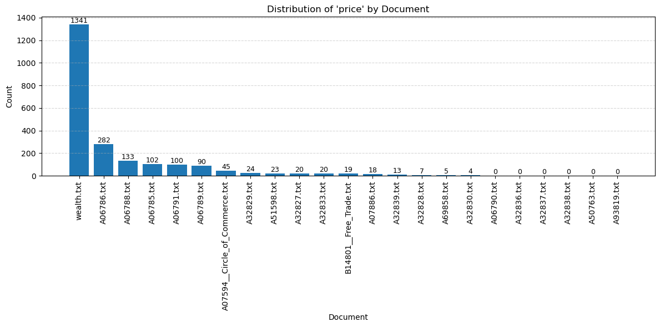Figure 1. Distribution of “price” by document
Figure 1 shows that the concept is not evenly distributed across the corpus. This uneven distribution suggests that “price” is a central term in some economic texts but only marginal in others.
Step 2 Named Entity Recognition (spaCy)
I focused on GPE, LOC, ORG, PERSON, and MONEY entities. The most frequent entities around “price” after NER show that ORG has the most frequent occurrences, include Exchange, Trade, commodities, and Bills, while the two entities that represent places appear more times, such as England, Europe, France, London, Holland, Spain, India, and Scotland. I think geographics has stronger pattern in this case. These results suggest that “price” is strongly connected to geography and market circulation. It is not only discussed as a description of how goods are exchanged, but also as something relevant to the economic behavior itself. This distinction has laid the foundation for the latter analysis of the meaning.
However, as could see from the list, some verbs such as ““Trade,” “Exchange,” and nouns “Cloth,” and “wares” are identified as entities. This means that the results are not accurate due to mistaken capitalized words. Although lower case for the corpus could reduce the incidence, it creates problems for text splitter as well. Another issue with NER is that a large share of the occurrences comes from one single document, wealth.txt. This means the patterns found may reflect the language style of this single document more than the corpus as a whole. Therefore, it should be cautious to simply use NER to characterize the whole corpus.
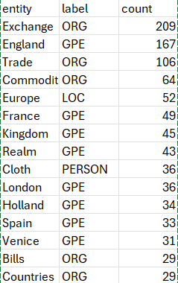
Table 1. Top Named Entities Around “Price”
Step 3 Contextual Meaning with BERT
To examine contextual meaning, I used BERT to generate embeddings for each occurrence of “price,” “prices,” and “priced.” Unlike a simple word count, BERT represents the word according to its sentence context but not a simple word count, so this allows the same word to have different vector representations when it appears in different contexts. I then used KMeans clustering to group similar contexts and UMAP to visualize the structure of the embeddings. The silhouette k test indicates that k =3 (k=2: 0.053, k=3: 0.0592, k=4: 0.0532, k=5: 0.0458) is ideal but conceptually, I prefer distinction I observe from the NER method, which means there are two concept groups. I first examined the two situations separately.
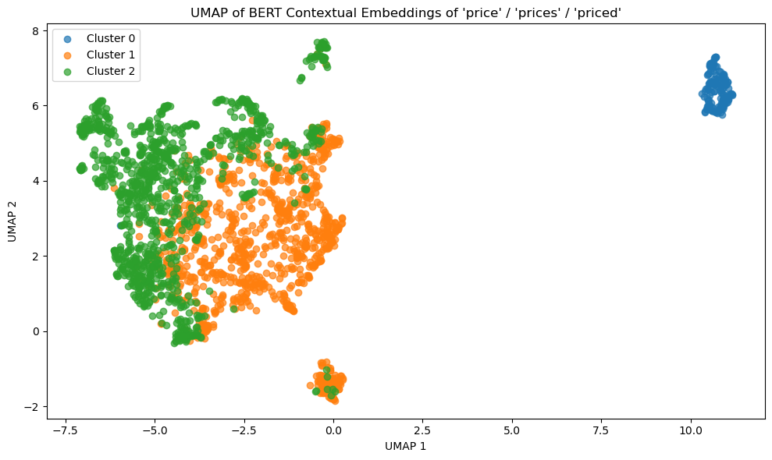
Figure 2.1. UMAP of BERT Contextual Embeddings K = 3
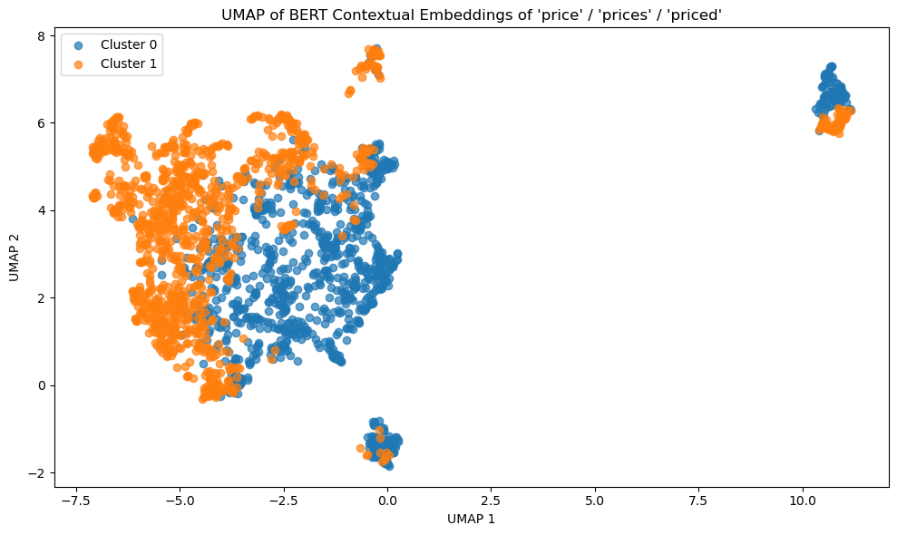
Figure 2.2. UMAP of BERT Contextual Embeddings K = 2

To better interpret the BERT clusters, I used TF-IDF to identify the most distinctive terms in each cluster. These terms help show what kinds of contexts surround the word “price” in different parts of the corpus. The results for two situations are below.
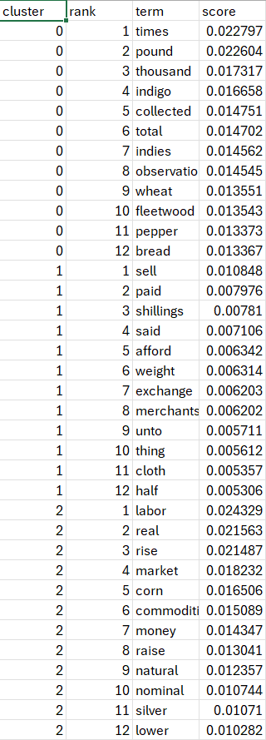
Table 2.1. Distinctive Terms by Cluster K = 3
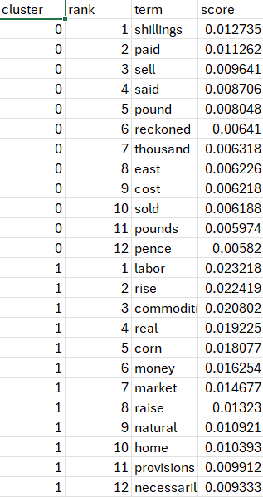
Table 2.2. Distinctive Terms by Cluster K = 2
From the results, K = 3 seems to have less conceptual clean results. One cluster contained terms such as “times,” “pound,” “thousand,” “indigo,” “Indies,” “wheat,” “pepper,” and “bread.” These terms seem to reflect a specific document topic or commodity list rather than a clearly separate meaning of “price.” By contrast, K = 2 case has cleaner conceptual groups. One cluster is marked by terms such as “shillings,” “paid,” “sell,” “pound,” “reckoned,” “cost,” “sold,” “pounds,” and “pence.” These terms suggest a monetary or transactional use of “price”. The other cluster is marked by terms such as “labor,” “rise,” “commodities,” “real,” “corn,” “money,” “market,” “raise,” “natural,” and “provisions.” These terms suggest a broader valuation-oriented use of “price,” price is connected to labor, commodities, market conditions, scarcity, and ideas of real or natural value.
However, these two meanings are not completely separate. Cluster 1 still includes “money,” and Cluster 0 still includes words such as “sell” and “cost,” which are also related to commodity value. The overlap is also displayed on the UMAP embeddings graph.
Example: (more can be found in report csv)
Label 0
wealth.txt: "To depress the price of this commodity below what
may be called its natural and proper price, was the avowed purpose of
those regulations; and there seems to be no doubt of their having produced
the effect that was expected from them."
Label 1
A06785.txt: Again, when the price of commodities is raised generally with the price of moneys enhanced; P. 25. shall we contradict the same, because one commodity, as Cloves, is not risen, but sold as a staple ware?
Step 4 Supervised Classification (Logistic Regression)
From the step 3 results, I summarized two categories of meaning for price: “market_exchange” and “valuation”. The market_exchange label refers to uses of “price” connected to circulated monetary number. The valuation label refers to uses of “price” as the assessed worth, value of goods or intrinsic value. I manually labeled 75 examples selected from k =3 BERT clusters. The cluster names here do not affect the classification results. The results show that the dataset included 47 examples of market_exchange and 28 examples of valuation. I trained a logistic regression classifier using TF-IDF features from the sentence contexts. The purpose of this step was to test whether market_exchange and valuation are linguistically distinct enough for a model to learn the difference.
The classification results show that the model did not distinguish the two meanings well. In the test set, the model predicted all examples as valuation. It correctly classified the 9 valuation examples, but it misclassified all 14 market_exchange examples. As a result, the market_exchange class had precision, recall, and F1 scores of 0.00. The overall accuracy was 0.39, but this number is misleading because the model collapsed into one-sided prediction rather than learning a balanced distinction between the two categories.
This weak performance suggests that the two meanings of “price” are difficult to separate with TF-IDF features alone. The labels are conceptually different, but the actual language surrounding them overlaps heavily. Both categories include words related to money, commodities, exchange, value, scarcity, trade, and market conditions. Therefore, the model’s failure is not only a technical problem. It also supports the broader interpretation that “price” is a semantically entangled concept in this corpus.
For feature interpretation, I first tried an L1 logistic regression model, but most coefficients were reduced to zero. I therefore used an L2 logistic regression model to examine the general direction of association between terms and labels. The L2 model retained 1,678 non-zero features out of 2,541 total features. Negative coefficients were associated with market_exchange, while positive coefficients were associated with valuation.
The L2 feature results should still be interpreted cautiously. The features associated with market_exchange include terms related to foreign trade, abundance, scarcity, and exchange. These terms fit the interpretation that this category treats price as part of circulation and market movement. The features associated with valuation include terms related to years, yield, delivery, and price over time. These features suggest that the model sometimes connects valuation with calculation, assessment, and temporal comparison. However, because the classifier performed poorly overall, these feature weights should not be read as strong evidence of stable semantic boundaries. They are better understood as weak signals in a dataset where the two meanings remain highly overlapping.
Overall, Step 4 shows that supervised classification can test the interpretive categories, but it does not fully confirm a clean division between them. The model’s weak performance supports my central claim: in this corpus, “price” moves between valuation and market exchange, but these meanings are not clearly separated. Instead, they are connected through shared economic vocabulary and historical discussions of trade.
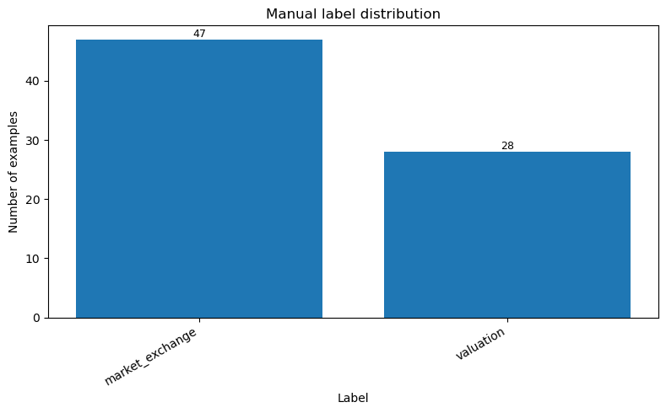
Figure 3. Manual Label Distribution
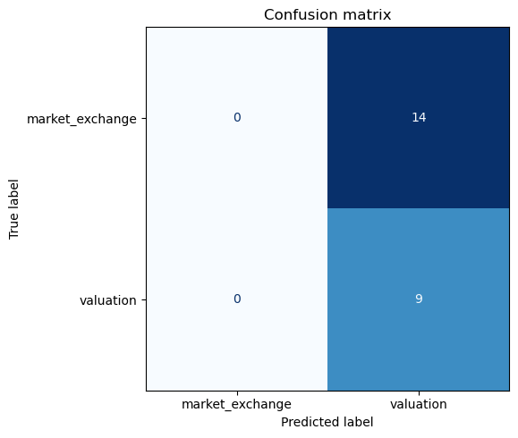
Figure 4. Confusion Matrix
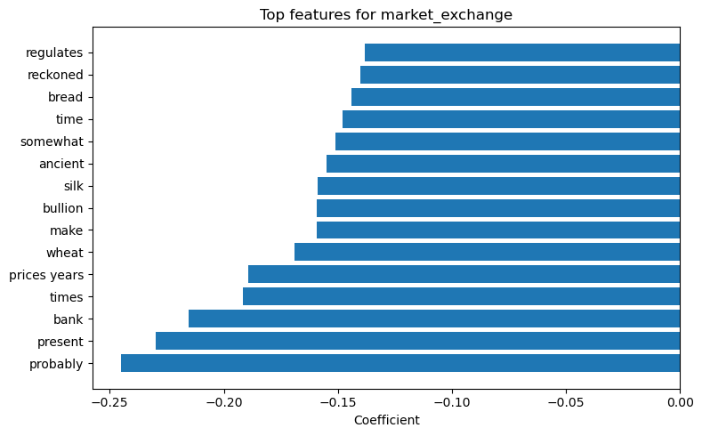
Figure 5. Top Features by market_exchange
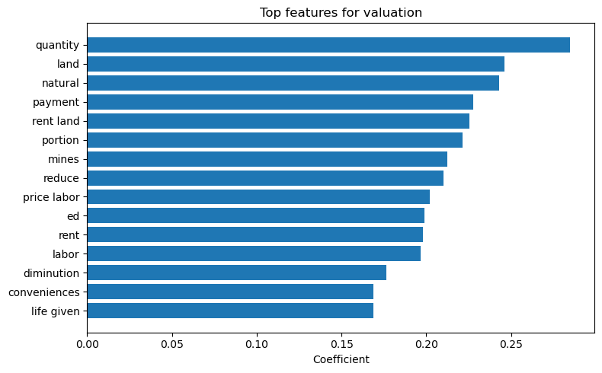Figure 6. Top Features by valuation
Step 5 Synthesis

Taken together, the results show that “price” has two major but overlapping meanings in the corpus. First, “price” functions as a term of valuation. In this use, it refers to the worth of commodities and is connected to labor, scarcity, production, and market conditions. Second, “price” functions as a term of market exchange, appears in discussions of money, exchange, payment, trade, and relations between countries.
To examine this relationship closer, I used a computationally assisted close reading method to identify overlapping meanings of “price.” I first used the distinctive TF-IDF terms from the BERT clusters to construct two semantic vocabularies. The first vocabulary represents monetary exchange and includes terms such as “shillings,” “paid,” “sell,” “pound,” “reckoned,” “cost,” “sold,” and “pence.” The second vocabulary represents commodity valuation and includes terms such as “labor,” “rise,” “commodities,” “real,” “corn,” “money,” “market,” “natural,” and “provisions.” I then searched for “price” contexts that contained terms from both vocabularies. To connect this close reading to the supervised classification step, I also used the L2 logistic regression model to identify examples where the model was uncertain between market_exchange and valuation. The final close-reading examples were selected from contexts with both lexical overlap and high model uncertainty.
The results complicate the apparent distinction between the two clusters. The TF-IDF terms suggest that the market_exchange contexts are often associated with words such as “pay,” “paid,” “sell,” “pound,” and “pence,” while the valuation contexts are more often associated with words such as “labor,” “market,” “commodities,” “real,” and “natural.” At first, this seems to support a distinction between price as monetary exchange and price as commodity valuation. However, this distinction is not clean. Some valuation-oriented passages still use numerical or payment-related language, while some exchange-oriented passages still involve questions of value, scarcity, and market conditions.
This overlap may reflect the historical character of the corpus. In these early modern economic texts, the conceptual distinction between market price, exchange value, and intrinsic or natural value does not appear to be fully stabilized. Price is often treated both as a monetary amount paid in exchange and as an expression of the value of goods. Therefore, words such as “pay,” “paid,” or “pence” do not necessarily indicate a purely transactional meaning, just as words such as “labor,” “market,” or “commodities”. The same context can contain both meanings at once.
This finding helps explain why the classifier struggled: the problem is not only that the model failed to classify the examples, but that the meanings themselves are historically and linguistically intertwined.

Example of Top Overlapping Contexts: See more in Appendix
"The commodity is then sold precisely for what it is worth, or for what it
really costs the person who brings it to market; for though, in common
language, what is called the prime cost of any commodity does not
comprehend the profit of the person who is to sell it again, yet, if he
sells it at a price which does not allow him the ordinary rate of profit
in his neighborhood, he is evidently a loser by the trade; since, by
employing his stock in some other way, he might have made that profit."

Reference
Devlin, Jacob, Ming-Wei Chang, Kenton Lee, and Kristina Toutanova. “BERT: Pre-training of Deep Bidirectional Transformers for Language Understanding.” In Proceedings of the 2019 Conference of the North American Chapter of the Association for Computational Linguistics: Human Language Technologies, 4171–4186. Minneapolis: Association for Computational Linguistics, 2019.
Ehrmann, Maud, Matteo Romanello, Alex Flückiger, and Simon Clematide. “Named Entity Recognition and Classification in Historical Documents: A Survey.” ACM Computing Surveys 56, no. 2 (2023): 1–47.
Ethayarajh, Kawin. “How Contextual Are Contextualized Word Representations? Comparing the Geometry of BERT, ELMo, and GPT-2 Embeddings.” In Proceedings of the 2019 Conference on Empirical Methods in Natural Language Processing and the 9th International Joint Conference on Natural Language Processing (EMNLP-IJCNLP), 55–65. Hong Kong: Association for Computational Linguistics, 2019.
Jurafsky, Daniel, and James H. Martin. Speech and Language Processing. 3rd ed. draft. Stanford, CA: Stanford University, 2025. Chapter 4, “Classification and Logistic Regression.”

Appendix
context | market_exchange_hits | valuation_hits | lexical_overlap_score | p_market_exchange | p_valuation | model_ambiguity | close_reading_score
Also we ought to esteem and cherish those trades which we have in remote or far Countries, for besides the increase of Shipping and Mariners thereby, the wares also sent thither and received from thence are far more profitable unto the kingdom than by our trades near at hand; As for example; suppose Pepper to be worth here two Shillings the pound constantly, if then it be brought from the Dutch at Amsterdam, the Merchant may give there twenty pence the pound, and gain well by the bargain; but if he fetch this Pepper from the Eastindies, he must not give above three pence the pound at the The traffic to the East Indies is our most profitable trade in its proportion both for King and Kingdom. most, which is a mighty advantage, not only in that part which serveth for our own use, but also for that great quantity which (from hence) we transport yearly unto divers other Nations to be sold at a higher price: whereby it is plain, that we make a far greater stock by gain upon these Indian Commodities, We get more by the Indian wares than the Indians themselves. than those Nations do where they grow, and to whom they properly appertain, being the natural wealth of their Countries. | east, pence, pound, shillings, sold | commodities, natural, worth | 8 | 0.568667 | 0.431333 | 0.862665 | 9.725331
The commodity is then sold precisely for what it is worth, or for what it  really costs the person who brings it to market; for though, in common  language, what is called the prime cost of any commodity does not  comprehend the profit of the person who is to sell it again, yet, if he  sells it at a price which does not allow him the ordinary rate of profit  in his neighborhood, he is evidently a loser by the trade; since, by  employing his stock in some other way, he might have made that profit. | cost, costs, sell, sold | commodity, market, worth | 7 | 0.504487 | 0.495513 | 0.991026 | 8.982052
A Merchant in Spain dealing for the West Indies, Nova Espagnia, Terra firma, or Peru and other places in America, will buy a round quantity of Germany commodities or manufactures made there, and in the Low Countries, either Yronmongers wares, as Hatchets, Axes, Knives, Bells, Beads, Needles, Basins, Candlesticks, Counters, Locks, Nails, and diverse sorts of commodities; and he is made acquainted by the Inuoice or Cargasson of those goods what they did cost in the places from whence they came, where the Merchant owner of the said wares, hath augmented his price in the said Invoice, and so the Spanish Merchant doth make him an offer of so many Maluidies for every pounds Flemish, or Hamborough money, Conditions to be observed in them. or for every dolor or other coin whereby the same was bought, according as the party by his observation is able to judge of the value thereof, by his often buying of the like: but the payment is agreed upon to be made sometime after the return of the West-Indies Fleet, that is to say, When most Ships going outwards shall return again into Spain, but whether the buyer of those goods do receive any return of the provenue of the said goods or not, is a matter not material to the seller of the goods, for he beareth no adventure of bad Factors, evil paymasters, or other accidents; but must be paid at the time agreed upon, according to the ordinary Custom thereof, unless it were agreed that he should bear the adventure of the Seas for a sum in certainty in nature of assurance, or upon some unexpected alteration, which might happen in the said assurance, which is another contract, as hereafter more amply will appear in his proper place. | cost, paid, payment, pounds | commodities, money, value | 7 | 0.518662 | 0.481338 | 0.962677 | 8.925354
By Bills of Exchange. 3 There is another buying and selling of commodities, to be paid by Bills of Exchanges, that is to say, The Buyer giveth a Bill of Exchange, or many Bills to be paid by exchange in another place; as for example one buyeth five hundreth pounds worth (at London) in commodities, which are accounted in price, as if he had bought them for ready money, and doth give unto the Seller of the said commodities one or more Bills of Exchanges for Antuerp, Amsterdam, or any other place, to be paid according to the price of exchange which is made, or aught to be made, according to the value of the monies of one Country, and the value of the monies of other Countries, by weight and fineness, as shall be hereafter declared, and that according to the distance and discrepance of the time and place, where and when the said monies shall be paid by the Buyers friend, Factor, or Servant; and so the said Bill or Bills of Exchanges are paid accordingly for the commodities so bought. | paid, pounds, selling | commodities, money, value, worth | 7 | 0.525434 | 0.474566 | 0.949132 | 8.898264
By Bills of Exchange. 3 There is another buying and selling of commodities, to be paid by Bills of Exchanges, that is to say, The Buyer giveth a Bill of Exchange, or many Bills to be paid by exchange in another place; as for example one buyeth five hundreth pounds worth (at London) in commodities, which are accounted in price, as if he had bought them for ready money, and doth give unto the Seller of the said commodities one or more Bills of Exchanges for Antuerp, Amsterdam, or any other place, to be paid according to the price of exchange which is made, or aught to be made, according to the value of the monies of one Country, and the value of the monies of other Countries, by weight and fineness, as shall be hereafter declared, and that according to the distance and discrepance of the time and place, where and when the said monies shall be paid by the Buyers friend, Factor, or Servant; and so the said Bill or Bills of Exchanges are paid accordingly for the commodities so bought. | paid, pounds, selling | commodities, money, value, worth | 7 | 0.525434 | 0.474566 | 0.949132 | 8.898264
THere is not any such thing in my writings, neither did I ever stand so much upon the necessary use of our Wools: but I did insist upon two principal points concerning the sale of Cloth, The advantage of the sale of our Cloth. which was, that other Nations (buying heretofore our Clothes, when they were sold dearer by the one half in price than they be now sold) did never complain that the Clothes were sold too dear, but they did always complain of the false making of Cloth: and again, that other Nations are as willing to sell unto us their foreign Commodities, as we can be to sell our Clothes to them: for those that make Clothes in their Countries, have no occasion to buy foreign Wares, or the Commodities of other Countries, but seek to sell them for ready money, or to be paid at some times of payment: whereby England hath a great advantage, and may enjoy the benefit of it in selling their Cloth with reputation, which is ever accompanied with request, and causeth Commodities to be sold at good rates; whereas vilifying the price of Wares, can never establish a Trade, nor make Commodities more vendible, and this requireth great consideration. | paid, payment, sell, selling, sold | commodities, money | 7 | 0.474326 | 0.525674 | 0.948651 | 8.897302
THere is not any such thing in my writings, neither did I ever stand so much upon the necessary use of our Wools: but I did insist upon two principal points concerning the sale of Cloth, The advantage of the sale of our Cloth. which was, that other Nations (buying heretofore our Clothes, when they were sold dearer by the one half in price than they be now sold) did never complain that the Clothes were sold too dear, but they did always complain of the false making of Cloth: and again, that other Nations are as willing to sell unto us their foreign Commodities, as we can be to sell our Clothes to them: for those that make Clothes in their Countries, have no occasion to buy foreign Wares, or the Commodities of other Countries, but seek to sell them for ready money, or to be paid at some times of payment: whereby England hath a great advantage, and may enjoy the benefit of it in selling their Cloth with reputation, which is ever accompanied with request, and causeth Commodities to be sold at good rates; whereas vilifying the price of Wares, can never establish a Trade, nor make Commodities more vendible, and this requireth great consideration. | paid, payment, sell, selling, sold | commodities, money | 7 | 0.474326 | 0.525674 | 0.948651 | 8.897302
Silver sunk in its real value, or would  exchange for a smaller quantity of labor than before; and corn rose in  its nominal price, and, instead of being commonly sold for about two  ounces of silver the quarter, or about ten shillings of our present money,  came to be sold for six and eight ounces of silver the quarter, or about  thirty and forty shillings of our present money. | shillings, sold | corn, labor, money, real, value | 7 | 0.527684 | 0.472316 | 0.944632 | 8.889263
THe Shillings of all the several Provinces respectively, and of the Mints of Nimogen, Deventer, Campen and Swoll 6 Stivers The half Shillings after the rate 3 Stivers The pieces called Flabs of Groninghen 4 stivers, the double 8 Stivers The twintigst part of the great silver Royal 2 ½ Stivers The double and single stivers of all these countries 2 & 1 Stiver  The tenth to be received in copper moneys 1 Of all which small moneys for the payments of rents, interest or abatement of the same, as also of all manner of Merchandise exceeding in one parcel the sum of one hundreth Guilders, no man shall be bound to receive more than the tenth penny.  2 The Duyts according to the order of the Provinces made in the Provincial Mints, and none other, are as yet tolerated for a Duyt: and all other copper moneys of the Provincial Mints are also tolerated to be paid out for one penny the piece, the 16 whereof make one Hollandts Stiver and not above; whereas we do intent hereafter to prohibit the same to be currant for any price, because we will provide ourselves forthwith with so much copper money as the commodiousness shall require.  3 We do also prohibit from henceforth no copper moneys to be brought into these countries above two stivers, upon pain often stivers for every piece to be forfeited: and whosoever shall issue any copper moneys above the said price, shall incur the like penalty of ten stivers for every piece.  4 And all the said coins shall be currant in these Provinces for the prices aforesaid, declaring all other pieces for bullion, All other coins made bullion to be melted. which by this Our proclamation are not valued, prohibiting any of the said pieces to be offered or received; as also to press any of those which are valued to be paid at a higher price than they are valued, and likewise offer to put forth other coins of gold and silver valued, which are clipped, washed, broken, mended, neiled or otherwise augmented in weight, upon forfeiture of all the said coins so to be offered at higher rates than this proclamation doth permit: and if the fact be not instantly discovered, to forfeit the value thereof, and moreover the quadruple or the value thereof, or 24 guilders in lieu thereof, if the said coins did not amount to six guilders for the first time, the second time double, and for the third time quadruple; and moreover arbitrable correction according to the quality of the fact.  5 Without that any distinction shall be made, whether the said coins were instantly paid from foreign parts, or sent from some one Province or Town into another, in which case, if the receiver thereof will be freed of the said forfeiture, he is to give notice of it within twenty and four hours after the receipt thereof unto the Magistrates or other Officers to be thereunto appointed, to the end they may proceed therein against the sender of the said coin, as it shall or may appertain.  6 Yet shall the said Receiver keep the said coins wholly to himself, if the said moneys be sent unto him in payment of a former debt, and nevertheless have his action against the party for so much as they shall want of the said valuation: and if the said coins be sent for any debt as yet not due, or to be made, the said Receiver shall reserve to himself so much as the forfeiture cometh unto, and the remainder shall be delivered to the said Magistrate or Officer.  7 The Magistrates in places also where all such moneys are sent at a higher rate than the said Proclamation, shall be bound to make good the said inhancing unto the Receiver to whom the said moneys were sent; yet so that they may redemaund the same of the Magistrate of the place from whence the said coins were sent, who shall also instantly reembourse the same and have power to recover it, with the forfeitures thereunto belonging, and hereby ordained against the persons and goods of those who have sent the same at a higher price.  8 All which shall be observed also from the one Province unto another, or the Counting-houses of the generality, wherein they shall be aiding and assisting each other, to maintain the said Proclamation accordingly.  9 And We do intent that the said forfeitures shall be imposed as well upon the receiver as upon the payer, every one to the full, unless one of the parties did forthwith denounce the same to the Magistrates, in which case (whether he be the receiver or payer) he shall be quit and free of the said forfeiture, and moreover enjoy the one third part of the offenders forfeiture.  10 Prohibiting and expressly commanding, that no man henceforth shall presume to buy or sell any wares or merchandises, or deal for moneys by exchange or interest, nor buy new or old rents, or otherwise deal and negotiate than according to the said price and valuation of moneys of this Our permission and Ordinance, upon forfeiture of the said sums, and moreover quadruple the value thereof.  11 Our intention being, That no payments of Imposts, Demesnes or Revenues of Lands, Towns, Villages, contracts of Merchandises, Hires, Rents, interest or any Debts shall be paid than according to this our valuation; to weet, every Gelder with the one half of a Lion Doller, and one pound Flemish with three Lion Dollars, or with other coins of gold and silver, according to their intrinsicke value, as the said Lion Doller, or the great Golden Royal now containeth. | paid, payment, pound, sell, shillings | money, value | 7 | 0.53263 | 0.46737 | 0.934741 | 8.869482
THe Shillings of all the several Provinces respectively, and of the Mints of Nimogen, Deventer, Campen and Swoll 6 Stivers The half Shillings after the rate 3 Stivers The pieces called Flabs of Groninghen 4 stivers, the double 8 Stivers The twintigst part of the great silver Royal 2 ½ Stivers The double and single stivers of all these countries 2 & 1 Stiver  The tenth to be received in copper moneys 1 Of all which small moneys for the payments of rents, interest or abatement of the same, as also of all manner of Merchandise exceeding in one parcel the sum of one hundreth Guilders, no man shall be bound to receive more than the tenth penny.  2 The Duyts according to the order of the Provinces made in the Provincial Mints, and none other, are as yet tolerated for a Duyt: and all other copper moneys of the Provincial Mints are also tolerated to be paid out for one penny the piece, the 16 whereof make one Hollandts Stiver and not above; whereas we do intent hereafter to prohibit the same to be currant for any price, because we will provide ourselves forthwith with so much copper money as the commodiousness shall require.  3 We do also prohibit from henceforth no copper moneys to be brought into these countries above two stivers, upon pain often stivers for every piece to be forfeited: and whosoever shall issue any copper moneys above the said price, shall incur the like penalty of ten stivers for every piece.  4 And all the said coins shall be currant in these Provinces for the prices aforesaid, declaring all other pieces for bullion, All other coins made bullion to be melted. which by this Our proclamation are not valued, prohibiting any of the said pieces to be offered or received; as also to press any of those which are valued to be paid at a higher price than they are valued, and likewise offer to put forth other coins of gold and silver valued, which are clipped, washed, broken, mended, neiled or otherwise augmented in weight, upon forfeiture of all the said coins so to be offered at higher rates than this proclamation doth permit: and if the fact be not instantly discovered, to forfeit the value thereof, and moreover the quadruple or the value thereof, or 24 guilders in lieu thereof, if the said coins did not amount to six guilders for the first time, the second time double, and for the third time quadruple; and moreover arbitrable correction according to the quality of the fact.  5 Without that any distinction shall be made, whether the said coins were instantly paid from foreign parts, or sent from some one Province or Town into another, in which case, if the receiver thereof will be freed of the said forfeiture, he is to give notice of it within twenty and four hours after the receipt thereof unto the Magistrates or other Officers to be thereunto appointed, to the end they may proceed therein against the sender of the said coin, as it shall or may appertain.  6 Yet shall the said Receiver keep the said coins wholly to himself, if the said moneys be sent unto him in payment of a former debt, and nevertheless have his action against the party for so much as they shall want of the said valuation: and if the said coins be sent for any debt as yet not due, or to be made, the said Receiver shall reserve to himself so much as the forfeiture cometh unto, and the remainder shall be delivered to the said Magistrate or Officer.  7 The Magistrates in places also where all such moneys are sent at a higher rate than the said Proclamation, shall be bound to make good the said inhancing unto the Receiver to whom the said moneys were sent; yet so that they may redemaund the same of the Magistrate of the place from whence the said coins were sent, who shall also instantly reembourse the same and have power to recover it, with the forfeitures thereunto belonging, and hereby ordained against the persons and goods of those who have sent the same at a higher price.  8 All which shall be observed also from the one Province unto another, or the Counting-houses of the generality, wherein they shall be aiding and assisting each other, to maintain the said Proclamation accordingly.  9 And We do intent that the said forfeitures shall be imposed as well upon the receiver as upon the payer, every one to the full, unless one of the parties did forthwith denounce the same to the Magistrates, in which case (whether he be the receiver or payer) he shall be quit and free of the said forfeiture, and moreover enjoy the one third part of the offenders forfeiture.  10 Prohibiting and expressly commanding, that no man henceforth shall presume to buy or sell any wares or merchandises, or deal for moneys by exchange or interest, nor buy new or old rents, or otherwise deal and negotiate than according to the said price and valuation of moneys of this Our permission and Ordinance, upon forfeiture of the said sums, and moreover quadruple the value thereof.  11 Our intention being, That no payments of Imposts, Demesnes or Revenues of Lands, Towns, Villages, contracts of Merchandises, Hires, Rents, interest or any Debts shall be paid than according to this our valuation; to weet, every Gelder with the one half of a Lion Doller, and one pound Flemish with three Lion Dollars, or with other coins of gold and silver, according to their intrinsicke value, as the said Lion Doller, or the great Golden Royal now containeth. | paid, payment, pound, sell, shillings | money, value | 7 | 0.53263 | 0.46737 | 0.934741 | 8.869482
THe Shillings of all the several Provinces respectively, and of the Mints of Nimogen, Deventer, Campen and Swoll 6 Stivers The half Shillings after the rate 3 Stivers The pieces called Flabs of Groninghen 4 stivers, the double 8 Stivers The twintigst part of the great silver Royal 2 ½ Stivers The double and single stivers of all these countries 2 & 1 Stiver  The tenth to be received in copper moneys 1 Of all which small moneys for the payments of rents, interest or abatement of the same, as also of all manner of Merchandise exceeding in one parcel the sum of one hundreth Guilders, no man shall be bound to receive more than the tenth penny.  2 The Duyts according to the order of the Provinces made in the Provincial Mints, and none other, are as yet tolerated for a Duyt: and all other copper moneys of the Provincial Mints are also tolerated to be paid out for one penny the piece, the 16 whereof make one Hollandts Stiver and not above; whereas we do intent hereafter to prohibit the same to be currant for any price, because we will provide ourselves forthwith with so much copper money as the commodiousness shall require.  3 We do also prohibit from henceforth no copper moneys to be brought into these countries above two stivers, upon pain often stivers for every piece to be forfeited: and whosoever shall issue any copper moneys above the said price, shall incur the like penalty of ten stivers for every piece.  4 And all the said coins shall be currant in these Provinces for the prices aforesaid, declaring all other pieces for bullion, All other coins made bullion to be melted. which by this Our proclamation are not valued, prohibiting any of the said pieces to be offered or received; as also to press any of those which are valued to be paid at a higher price than they are valued, and likewise offer to put forth other coins of gold and silver valued, which are clipped, washed, broken, mended, neiled or otherwise augmented in weight, upon forfeiture of all the said coins so to be offered at higher rates than this proclamation doth permit: and if the fact be not instantly discovered, to forfeit the value thereof, and moreover the quadruple or the value thereof, or 24 guilders in lieu thereof, if the said coins did not amount to six guilders for the first time, the second time double, and for the third time quadruple; and moreover arbitrable correction according to the quality of the fact.  5 Without that any distinction shall be made, whether the said coins were instantly paid from foreign parts, or sent from some one Province or Town into another, in which case, if the receiver thereof will be freed of the said forfeiture, he is to give notice of it within twenty and four hours after the receipt thereof unto the Magistrates or other Officers to be thereunto appointed, to the end they may proceed therein against the sender of the said coin, as it shall or may appertain.  6 Yet shall the said Receiver keep the said coins wholly to himself, if the said moneys be sent unto him in payment of a former debt, and nevertheless have his action against the party for so much as they shall want of the said valuation: and if the said coins be sent for any debt as yet not due, or to be made, the said Receiver shall reserve to himself so much as the forfeiture cometh unto, and the remainder shall be delivered to the said Magistrate or Officer.  7 The Magistrates in places also where all such moneys are sent at a higher rate than the said Proclamation, shall be bound to make good the said inhancing unto the Receiver to whom the said moneys were sent; yet so that they may redemaund the same of the Magistrate of the place from whence the said coins were sent, who shall also instantly reembourse the same and have power to recover it, with the forfeitures thereunto belonging, and hereby ordained against the persons and goods of those who have sent the same at a higher price.  8 All which shall be observed also from the one Province unto another, or the Counting-houses of the generality, wherein they shall be aiding and assisting each other, to maintain the said Proclamation accordingly.  9 And We do intent that the said forfeitures shall be imposed as well upon the receiver as upon the payer, every one to the full, unless one of the parties did forthwith denounce the same to the Magistrates, in which case (whether he be the receiver or payer) he shall be quit and free of the said forfeiture, and moreover enjoy the one third part of the offenders forfeiture.  10 Prohibiting and expressly commanding, that no man henceforth shall presume to buy or sell any wares or merchandises, or deal for moneys by exchange or interest, nor buy new or old rents, or otherwise deal and negotiate than according to the said price and valuation of moneys of this Our permission and Ordinance, upon forfeiture of the said sums, and moreover quadruple the value thereof.  11 Our intention being, That no payments of Imposts, Demesnes or Revenues of Lands, Towns, Villages, contracts of Merchandises, Hires, Rents, interest or any Debts shall be paid than according to this our valuation; to weet, every Gelder with the one half of a Lion Doller, and one pound Flemish with three Lion Dollars, or with other coins of gold and silver, according to their intrinsicke value, as the said Lion Doller, or the great Golden Royal now containeth. | paid, payment, pound, sell, shillings | money, value | 7 | 0.53263 | 0.46737 | 0.934741 | 8.869482
THe Shillings of all the several Provinces respectively, and of the Mints of Nimogen, Deventer, Campen and Swoll 6 Stivers The half Shillings after the rate 3 Stivers The pieces called Flabs of Groninghen 4 stivers, the double 8 Stivers The twintigst part of the great silver Royal 2 ½ Stivers The double and single stivers of all these countries 2 & 1 Stiver  The tenth to be received in copper moneys 1 Of all which small moneys for the payments of rents, interest or abatement of the same, as also of all manner of Merchandise exceeding in one parcel the sum of one hundreth Guilders, no man shall be bound to receive more than the tenth penny.  2 The Duyts according to the order of the Provinces made in the Provincial Mints, and none other, are as yet tolerated for a Duyt: and all other copper moneys of the Provincial Mints are also tolerated to be paid out for one penny the piece, the 16 whereof make one Hollandts Stiver and not above; whereas we do intent hereafter to prohibit the same to be currant for any price, because we will provide ourselves forthwith with so much copper money as the commodiousness shall require.  3 We do also prohibit from henceforth no copper moneys to be brought into these countries above two stivers, upon pain often stivers for every piece to be forfeited: and whosoever shall issue any copper moneys above the said price, shall incur the like penalty of ten stivers for every piece.  4 And all the said coins shall be currant in these Provinces for the prices aforesaid, declaring all other pieces for bullion, All other coins made bullion to be melted. which by this Our proclamation are not valued, prohibiting any of the said pieces to be offered or received; as also to press any of those which are valued to be paid at a higher price than they are valued, and likewise offer to put forth other coins of gold and silver valued, which are clipped, washed, broken, mended, neiled or otherwise augmented in weight, upon forfeiture of all the said coins so to be offered at higher rates than this proclamation doth permit: and if the fact be not instantly discovered, to forfeit the value thereof, and moreover the quadruple or the value thereof, or 24 guilders in lieu thereof, if the said coins did not amount to six guilders for the first time, the second time double, and for the third time quadruple; and moreover arbitrable correction according to the quality of the fact.  5 Without that any distinction shall be made, whether the said coins were instantly paid from foreign parts, or sent from some one Province or Town into another, in which case, if the receiver thereof will be freed of the said forfeiture, he is to give notice of it within twenty and four hours after the receipt thereof unto the Magistrates or other Officers to be thereunto appointed, to the end they may proceed therein against the sender of the said coin, as it shall or may appertain.  6 Yet shall the said Receiver keep the said coins wholly to himself, if the said moneys be sent unto him in payment of a former debt, and nevertheless have his action against the party for so much as they shall want of the said valuation: and if the said coins be sent for any debt as yet not due, or to be made, the said Receiver shall reserve to himself so much as the forfeiture cometh unto, and the remainder shall be delivered to the said Magistrate or Officer.  7 The Magistrates in places also where all such moneys are sent at a higher rate than the said Proclamation, shall be bound to make good the said inhancing unto the Receiver to whom the said moneys were sent; yet so that they may redemaund the same of the Magistrate of the place from whence the said coins were sent, who shall also instantly reembourse the same and have power to recover it, with the forfeitures thereunto belonging, and hereby ordained against the persons and goods of those who have sent the same at a higher price.  8 All which shall be observed also from the one Province unto another, or the Counting-houses of the generality, wherein they shall be aiding and assisting each other, to maintain the said Proclamation accordingly.  9 And We do intent that the said forfeitures shall be imposed as well upon the receiver as upon the payer, every one to the full, unless one of the parties did forthwith denounce the same to the Magistrates, in which case (whether he be the receiver or payer) he shall be quit and free of the said forfeiture, and moreover enjoy the one third part of the offenders forfeiture.  10 Prohibiting and expressly commanding, that no man henceforth shall presume to buy or sell any wares or merchandises, or deal for moneys by exchange or interest, nor buy new or old rents, or otherwise deal and negotiate than according to the said price and valuation of moneys of this Our permission and Ordinance, upon forfeiture of the said sums, and moreover quadruple the value thereof.  11 Our intention being, That no payments of Imposts, Demesnes or Revenues of Lands, Towns, Villages, contracts of Merchandises, Hires, Rents, interest or any Debts shall be paid than according to this our valuation; to weet, every Gelder with the one half of a Lion Doller, and one pound Flemish with three Lion Dollars, or with other coins of gold and silver, according to their intrinsicke value, as the said Lion Doller, or the great Golden Royal now containeth. | paid, payment, pound, sell, shillings | money, value | 7 | 0.53263 | 0.46737 | 0.934741 | 8.869482
THe Shillings of all the several Provinces respectively, and of the Mints of Nimogen, Deventer, Campen and Swoll 6 Stivers The half Shillings after the rate 3 Stivers The pieces called Flabs of Groninghen 4 stivers, the double 8 Stivers The twintigst part of the great silver Royal 2 ½ Stivers The double and single stivers of all these countries 2 & 1 Stiver  The tenth to be received in copper moneys 1 Of all which small moneys for the payments of rents, interest or abatement of the same, as also of all manner of Merchandise exceeding in one parcel the sum of one hundreth Guilders, no man shall be bound to receive more than the tenth penny.  2 The Duyts according to the order of the Provinces made in the Provincial Mints, and none other, are as yet tolerated for a Duyt: and all other copper moneys of the Provincial Mints are also tolerated to be paid out for one penny the piece, the 16 whereof make one Hollandts Stiver and not above; whereas we do intent hereafter to prohibit the same to be currant for any price, because we will provide ourselves forthwith with so much copper money as the commodiousness shall require.  3 We do also prohibit from henceforth no copper moneys to be brought into these countries above two stivers, upon pain often stivers for every piece to be forfeited: and whosoever shall issue any copper moneys above the said price, shall incur the like penalty of ten stivers for every piece.  4 And all the said coins shall be currant in these Provinces for the prices aforesaid, declaring all other pieces for bullion, All other coins made bullion to be melted. which by this Our proclamation are not valued, prohibiting any of the said pieces to be offered or received; as also to press any of those which are valued to be paid at a higher price than they are valued, and likewise offer to put forth other coins of gold and silver valued, which are clipped, washed, broken, mended, neiled or otherwise augmented in weight, upon forfeiture of all the said coins so to be offered at higher rates than this proclamation doth permit: and if the fact be not instantly discovered, to forfeit the value thereof, and moreover the quadruple or the value thereof, or 24 guilders in lieu thereof, if the said coins did not amount to six guilders for the first time, the second time double, and for the third time quadruple; and moreover arbitrable correction according to the quality of the fact.  5 Without that any distinction shall be made, whether the said coins were instantly paid from foreign parts, or sent from some one Province or Town into another, in which case, if the receiver thereof will be freed of the said forfeiture, he is to give notice of it within twenty and four hours after the receipt thereof unto the Magistrates or other Officers to be thereunto appointed, to the end they may proceed therein against the sender of the said coin, as it shall or may appertain.  6 Yet shall the said Receiver keep the said coins wholly to himself, if the said moneys be sent unto him in payment of a former debt, and nevertheless have his action against the party for so much as they shall want of the said valuation: and if the said coins be sent for any debt as yet not due, or to be made, the said Receiver shall reserve to himself so much as the forfeiture cometh unto, and the remainder shall be delivered to the said Magistrate or Officer.  7 The Magistrates in places also where all such moneys are sent at a higher rate than the said Proclamation, shall be bound to make good the said inhancing unto the Receiver to whom the said moneys were sent; yet so that they may redemaund the same of the Magistrate of the place from whence the said coins were sent, who shall also instantly reembourse the same and have power to recover it, with the forfeitures thereunto belonging, and hereby ordained against the persons and goods of those who have sent the same at a higher price.  8 All which shall be observed also from the one Province unto another, or the Counting-houses of the generality, wherein they shall be aiding and assisting each other, to maintain the said Proclamation accordingly.  9 And We do intent that the said forfeitures shall be imposed as well upon the receiver as upon the payer, every one to the full, unless one of the parties did forthwith denounce the same to the Magistrates, in which case (whether he be the receiver or payer) he shall be quit and free of the said forfeiture, and moreover enjoy the one third part of the offenders forfeiture.  10 Prohibiting and expressly commanding, that no man henceforth shall presume to buy or sell any wares or merchandises, or deal for moneys by exchange or interest, nor buy new or old rents, or otherwise deal and negotiate than according to the said price and valuation of moneys of this Our permission and Ordinance, upon forfeiture of the said sums, and moreover quadruple the value thereof.  11 Our intention being, That no payments of Imposts, Demesnes or Revenues of Lands, Towns, Villages, contracts of Merchandises, Hires, Rents, interest or any Debts shall be paid than according to this our valuation; to weet, every Gelder with the one half of a Lion Doller, and one pound Flemish with three Lion Dollars, or with other coins of gold and silver, according to their intrinsicke value, as the said Lion Doller, or the great Golden Royal now containeth. | paid, payment, pound, sell, shillings | money, value | 7 | 0.53263 | 0.46737 | 0.934741 | 8.869482
THe Shillings of all the several Provinces respectively, and of the Mints of Nimogen, Deventer, Campen and Swoll 6 Stivers The half Shillings after the rate 3 Stivers The pieces called Flabs of Groninghen 4 stivers, the double 8 Stivers The twintigst part of the great silver Royal 2 ½ Stivers The double and single stivers of all these countries 2 & 1 Stiver  The tenth to be received in copper moneys 1 Of all which small moneys for the payments of rents, interest or abatement of the same, as also of all manner of Merchandise exceeding in one parcel the sum of one hundreth Guilders, no man shall be bound to receive more than the tenth penny.  2 The Duyts according to the order of the Provinces made in the Provincial Mints, and none other, are as yet tolerated for a Duyt: and all other copper moneys of the Provincial Mints are also tolerated to be paid out for one penny the piece, the 16 whereof make one Hollandts Stiver and not above; whereas we do intent hereafter to prohibit the same to be currant for any price, because we will provide ourselves forthwith with so much copper money as the commodiousness shall require.  3 We do also prohibit from henceforth no copper moneys to be brought into these countries above two stivers, upon pain often stivers for every piece to be forfeited: and whosoever shall issue any copper moneys above the said price, shall incur the like penalty of ten stivers for every piece.  4 And all the said coins shall be currant in these Provinces for the prices aforesaid, declaring all other pieces for bullion, All other coins made bullion to be melted. which by this Our proclamation are not valued, prohibiting any of the said pieces to be offered or received; as also to press any of those which are valued to be paid at a higher price than they are valued, and likewise offer to put forth other coins of gold and silver valued, which are clipped, washed, broken, mended, neiled or otherwise augmented in weight, upon forfeiture of all the said coins so to be offered at higher rates than this proclamation doth permit: and if the fact be not instantly discovered, to forfeit the value thereof, and moreover the quadruple or the value thereof, or 24 guilders in lieu thereof, if the said coins did not amount to six guilders for the first time, the second time double, and for the third time quadruple; and moreover arbitrable correction according to the quality of the fact.  5 Without that any distinction shall be made, whether the said coins were instantly paid from foreign parts, or sent from some one Province or Town into another, in which case, if the receiver thereof will be freed of the said forfeiture, he is to give notice of it within twenty and four hours after the receipt thereof unto the Magistrates or other Officers to be thereunto appointed, to the end they may proceed therein against the sender of the said coin, as it shall or may appertain.  6 Yet shall the said Receiver keep the said coins wholly to himself, if the said moneys be sent unto him in payment of a former debt, and nevertheless have his action against the party for so much as they shall want of the said valuation: and if the said coins be sent for any debt as yet not due, or to be made, the said Receiver shall reserve to himself so much as the forfeiture cometh unto, and the remainder shall be delivered to the said Magistrate or Officer.  7 The Magistrates in places also where all such moneys are sent at a higher rate than the said Proclamation, shall be bound to make good the said inhancing unto the Receiver to whom the said moneys were sent; yet so that they may redemaund the same of the Magistrate of the place from whence the said coins were sent, who shall also instantly reembourse the same and have power to recover it, with the forfeitures thereunto belonging, and hereby ordained against the persons and goods of those who have sent the same at a higher price.  8 All which shall be observed also from the one Province unto another, or the Counting-houses of the generality, wherein they shall be aiding and assisting each other, to maintain the said Proclamation accordingly.  9 And We do intent that the said forfeitures shall be imposed as well upon the receiver as upon the payer, every one to the full, unless one of the parties did forthwith denounce the same to the Magistrates, in which case (whether he be the receiver or payer) he shall be quit and free of the said forfeiture, and moreover enjoy the one third part of the offenders forfeiture.  10 Prohibiting and expressly commanding, that no man henceforth shall presume to buy or sell any wares or merchandises, or deal for moneys by exchange or interest, nor buy new or old rents, or otherwise deal and negotiate than according to the said price and valuation of moneys of this Our permission and Ordinance, upon forfeiture of the said sums, and moreover quadruple the value thereof.  11 Our intention being, That no payments of Imposts, Demesnes or Revenues of Lands, Towns, Villages, contracts of Merchandises, Hires, Rents, interest or any Debts shall be paid than according to this our valuation; to weet, every Gelder with the one half of a Lion Doller, and one pound Flemish with three Lion Dollars, or with other coins of gold and silver, according to their intrinsicke value, as the said Lion Doller, or the great Golden Royal now containeth. | paid, payment, pound, sell, shillings | money, value | 7 | 0.53263 | 0.46737 | 0.934741 | 8.869482
The low money price for which they may  be sold, is no proof that the real value of silver is there very high, but  that the real value of those commodities is very low.  labor, it must always be remembered, and not any particular commodity, or  set of commodities, is the real measure of the value both of silver and of  all other commodities. | sold | commodities, commodity, labor, money, real, value | 7 | 0.459855 | 0.540145 | 0.919709 | 8.839419
The market price of every particular commodity is regulated by the  proportion between the quantity which is actually brought to market, and  the demand of those who are willing to pay the natural price of the  commodity, or the whole value of the rent, labor, and profit, which must  be paid in order to bring it thither. | paid, pay | commodity, labor, market, natural, value | 7 | 0.454026 | 0.545975 | 0.908051 | 8.816102
The market price of every particular commodity is regulated by the  proportion between the quantity which is actually brought to market, and  the demand of those who are willing to pay the natural price of the  commodity, or the whole value of the rent, labor, and profit, which must  be paid in order to bring it thither. | paid, pay | commodity, labor, market, natural, value | 7 | 0.454026 | 0.545975 | 0.908051 | 8.816102
FIrst, when our moneys are undervalued in exchange, whereby there ariseth a gain between the inward value of the moneys and the price of exchange: then are our moneys continually exported into foreign parts, for the like gain can never be made by any Commodity.  2 This exportation of money, causeth not only the less moneys to be employed upon our native Commodities, and returneth in foreign wares, but taketh away also the Vital spirit of Traffic, and giveth a great cause of overbalancing of commodities.  3 The said undervaluation of our moneys in exchange doth the like, and causeth our native Commodities to be sold better cheap beyond the Seas, for want of knowledge of the true value of our moneys and theirs: even as the enhancing of foreign coin beyond the Seas, caused the foreign wares to be advanced in price, according as the said money is enhanced, whereby the said overbalancing must needs come to pass of course.  4 It doth hinder the importation of Bullion and Dollars from the said places of Trade, which we have had in times past: for the said enhancing coin not being truly valued by exchange, cannot be imported but to an exceeding loss, and Merchant strangers will not take the same at a low exchange, so that our Merchants are compelled to make their returns by foreign Commodities, thereby greatly increasing the said overbalancing of Trade.  5 Young English Merchants are constrained to take up a great part of the said money at a low exchange, to maintain their rechanges to their loss, or else must make quick sales of their commodities, whereby they spoil the markets of others, which causeth them to set over their bills obligatory (received for their Clothes sold there) either for money, to pay the money taken up here by exchange, or for foreign Commodities at dear rates by the said enhanced moneys and otherwise, which cannot but breed an overbalancing of Commodities.  6 The said low exchange (whereby the Spanish Merchants make a diversion of the royals of 8 unto to those parts finding there more gain, when they can make over their moneys by a low exchange doth also divert from us a great Trade, by such employments as are made there upon foreign Commodities, as Bays, Says, and other new Draperies made in those parts, which might be employed upon our Commodities, and can this negotiation be without argumenting of the said overbalancing?  7 If by occasion or accident moneys or Bullion is impotted: (which might be carried to the Mint, and the moneys made thereof would be delivered by exchange to our Merchants, and so by them employed upon our Commodities, if the said were high or indiffetent:) it falleth out, that the said moneys or Bullion are exported again by other Merchants, which bring in foreign wares for it, for gain still beareth the sway. | pay, sold | commodities, commodity, markets, money, value | 7 | 0.548088 | 0.451912 | 0.903824 | 8.807647
FIrst, when our moneys are undervalued in exchange, whereby there ariseth a gain between the inward value of the moneys and the price of exchange: then are our moneys continually exported into foreign parts, for the like gain can never be made by any Commodity.  2 This exportation of money, causeth not only the less moneys to be employed upon our native Commodities, and returneth in foreign wares, but taketh away also the Vital spirit of Traffic, and giveth a great cause of overbalancing of commodities.  3 The said undervaluation of our moneys in exchange doth the like, and causeth our native Commodities to be sold better cheap beyond the Seas, for want of knowledge of the true value of our moneys and theirs: even as the enhancing of foreign coin beyond the Seas, caused the foreign wares to be advanced in price, according as the said money is enhanced, whereby the said overbalancing must needs come to pass of course.  4 It doth hinder the importation of Bullion and Dollars from the said places of Trade, which we have had in times past: for the said enhancing coin not being truly valued by exchange, cannot be imported but to an exceeding loss, and Merchant strangers will not take the same at a low exchange, so that our Merchants are compelled to make their returns by foreign Commodities, thereby greatly increasing the said overbalancing of Trade.  5 Young English Merchants are constrained to take up a great part of the said money at a low exchange, to maintain their rechanges to their loss, or else must make quick sales of their commodities, whereby they spoil the markets of others, which causeth them to set over their bills obligatory (received for their Clothes sold there) either for money, to pay the money taken up here by exchange, or for foreign Commodities at dear rates by the said enhanced moneys and otherwise, which cannot but breed an overbalancing of Commodities.  6 The said low exchange (whereby the Spanish Merchants make a diversion of the royals of 8 unto to those parts finding there more gain, when they can make over their moneys by a low exchange doth also divert from us a great Trade, by such employments as are made there upon foreign Commodities, as Bays, Says, and other new Draperies made in those parts, which might be employed upon our Commodities, and can this negotiation be without argumenting of the said overbalancing?  7 If by occasion or accident moneys or Bullion is impotted: (which might be carried to the Mint, and the moneys made thereof would be delivered by exchange to our Merchants, and so by them employed upon our Commodities, if the said were high or indiffetent:) it falleth out, that the said moneys or Bullion are exported again by other Merchants, which bring in foreign wares for it, for gain still beareth the sway. | pay, sold | commodities, commodity, markets, money, value | 7 | 0.548088 | 0.451912 | 0.903824 | 8.807647
Though in consequence of the bounty, therefore, the farmer should be  enabled to sell his corn for 4s. the bushel, instead of 3s:6d. and to pay  his landlord a money rent proportionable to this rise in the money price  of his produce; yet if, in consequence of this rise in the price of corn,  4s. will purchase no more home made goods of any other kind than 3s. 6d.  would have done before, neither the circumstances of the farmer, nor those  of the landlord, will be much mended by this change. | pay, sell | corn, home, money, rise | 6 | 0.499724 | 0.500276 | 0.999449 | 7.998897

